Project Idea:   
**Platformer in PyGame**

**Concept**

The project I am currently working on, and would like to submit at the end of this term, is a basic platformer built in python using the pyGame library.

The game is similar to the likes of other popular platformers, with the goal being to get to one end of the level to the other, collecting objectives (in this case, coins) to complete the level.

The twist is that score will be tied directly to the distance and time taken to reach the goal, with coins improving the score, but placed off the fastest path.

You may want to complete the level by taking the shortest, fastest route and practice this, or you may choose to take less optimal routes to collect coins for greater score.

**Specification**

The game has a number of core features which I intend to complete in full, as well as a number of optional features which will improve the gameplay, aesthetic, and other aspects of the project despite not being necessary.

*Core* features include:

* At least 4 playable levels.
  + Level creation and loading system through images.
  + Selecting and progressing linearly through levels.
* Score system based on time and distance to objectives.
* Menu system.
  + Show locked/unlocked levels.
  + Play, Exit, Load Game, New Game buttons.
  + Pause menu while in-game.
* 4 different blocktypes which the player interacts with in-game.
  + Blocks – which cannot be passed through on any side.
  + Platforms – which can be passed through from below, but not from above.
  + Coins – Can be collected by the player in order to improve the player’s score.
  + Flag – The objective, which the player must reach to complete the level.
* File handling system
  + Allow the player to save their progress, such as unlocked levels and total/high scores.
  + Loading image sprites to represent the player, and other entities on the screen.
  + Level loading system which loads image files from the game directory, interprets them in order to load the sprites onto the screen.
* Side-scrolling to accommodate for different-sized levels.

*Other* bonus features include:

* Sound system for SFX, such as falling, jumping, collecting coins etc. using the pyGame mixer modules.
* Particles effects for when the player jumps, lands, collects coins.
* Sprite animations.
* In-game Music.
* Parallax Background art.
* Extra levels.
* Multiple player save files.

Other bonus features may be decided on and added later, as these are simply just examples that I would initially like to add if I complete the project ahead of schedule.

**Progress so far**

Many of the core features have been completed already. The game in its current state features the level loading system, all the block-types with their collision properties working as intended, side-scrolling functionality and basic sprites.

The most recent build as of today (12/10/2017) is shown below:

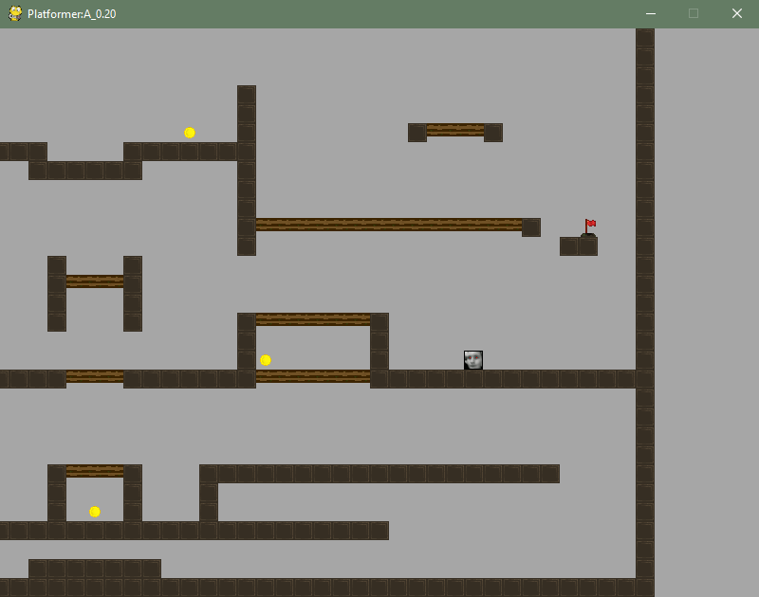

Menu and scoring systems have yet to be implemented, as I have been working on the core gameplay, but I have completed similar projects with UI elements before, and thus these features shouldn’t be too timely.

**GitHub Access**

The current version of the game can be found at the following GitHub link:

<https://github.com/TDuffin/Platformer-Github>

And can be played by running the “Main.py” file from within the project folder.